**Datastax DevCenter & OpsCenter Installation Complete Guide**

In this tutorial, you will learn,

* [DevCenter Installation](https://www.guru99.com/cassandra-devcenter-opscenter.html#1)
* [OpsCenter Installation](https://www.guru99.com/cassandra-devcenter-opscenter.html#2)

**DevCenter Installation**

DevCenter is the front end query tool where you can write your query and execute it. DevCenter is provided by the Datastax.

Here are the steps of running DevCenter installation;

**Step 1)** First of all, [download](https://www.guru99.com/cassandra-devcenter-opscenter.html) DevCenter from the datastax site.

**Step 2)** Go to DevCenter directory and execute DevCenter executable file.

[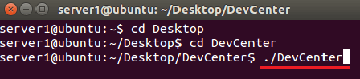](https://cdn.guru99.com/images/cassandra/021216_0520_DevCenterOp1.png)

After running above command, following page will be displayed. Below form is the user interface for DevCenter.

**Step 3)** In this step, you must create a connection with Cassandra enterprise server. Go to connection window and click on the icon as shown here

[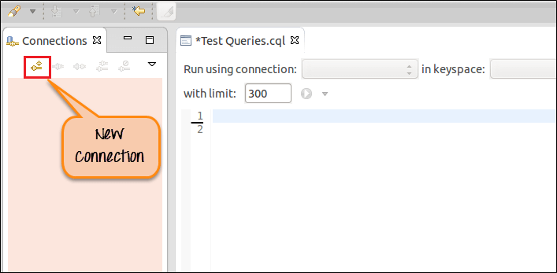](https://cdn.guru99.com/images/cassandra/021216_0520_DevCenterOp2.png)

* Make sure that Cassandra enterprise server is running
* Click on the red rectangle (in the above screenshot) for creating a connection.

**Step 4)** After clicking on it, you will be displayed on the following page.

1. Give connection name, you can give any connection name. This is not a specific thing.
2. Provide IP address of the node as Contact hosts.
3. Provide [port](https://www.guru99.com/cassandra-devcenter-opscenter.html) number, by default port, is 9042.
4. Next select compression type
5. After providing this information, press finish button.

[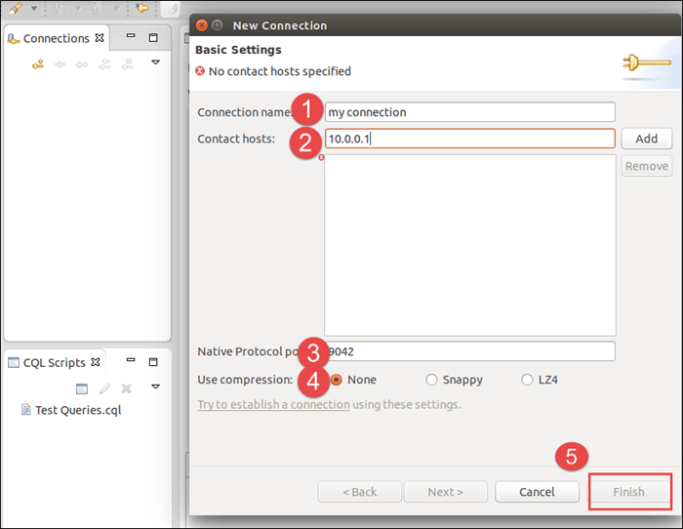](https://cdn.guru99.com/images/cassandra/021216_0520_DevCenterOp3.png)

After this, DevCenter should run successfully.

Here is the screenshot that displays different parts in the DevCenter User interface.

[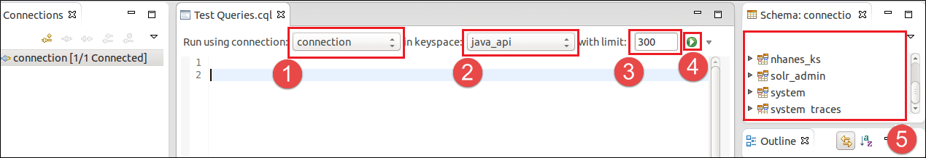](https://cdn.guru99.com/images/cassandra/021216_0520_DevCenterOp4.png)

1. Select "connection" from the drop down. Usually, you have only one connection that you have been created.
2. Select keyspace from the drop down from which you want to query data.
3. Select a number of records that you want to retrieve and display on the DevCenter User interface.
4. Execute button to execute the query.
5. Here is the little form where all the keyspaces are displayed. The system provides us with some keyspaces like System_traces and System. While some keyspaces are created by the user such as nhanes_ks.

Here is the screenshot that shows how to query data and where query results are displayed.

[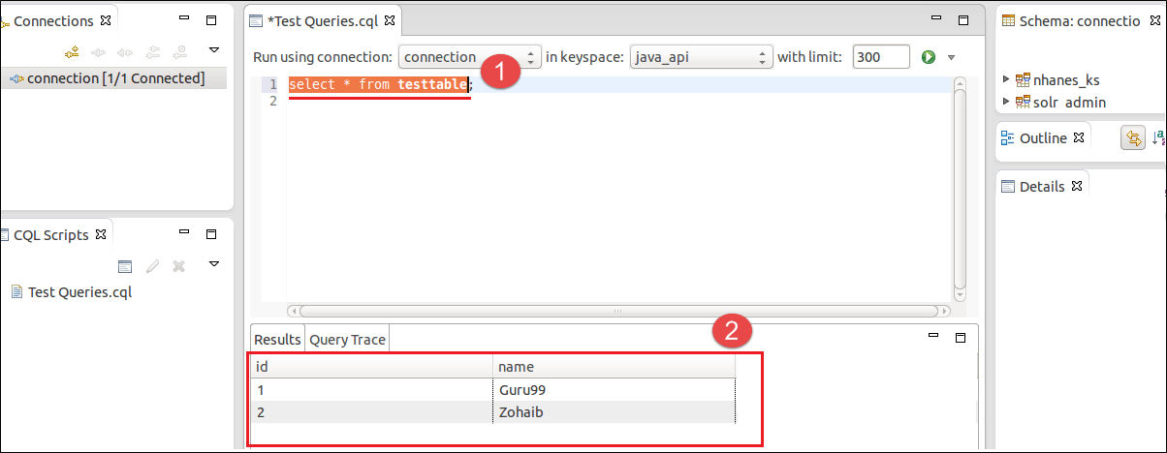](https://cdn.guru99.com/images/cassandra/021216_0520_DevCenterOp5.png)

1. Write query on the above form where the number is displayed. Select the query and press [Datastax DevCenter & OpsCenter Installation Complete Guide](https://cdn.guru99.com/images/cassandra/021216_0520_DevCenterOp6.png)execute button.
2. After query selection and execute the button, you will be displayed the query result as shown above with number 2. There are two columns in the table testable in the java_api keyspace. Column names are id and name. There are only two records in the table testtable.

**OpsCenter Installation**

OpsCenter is the visual management and monitoring tool for[Apache](https://www.guru99.com/apache.html)Cassandra and Datastax enterprise. This is a very helpful tool for architects, database administrators, and database operators.

In large organizations, they have thousands of servers. It is very difficult to monitor these servers that which server is running and which server is down. OpsCenter is the tool where you can monitor all the Cassandra nodes by sitting and watching on a single machine.

This tutorial is step by step guidance on how to setup OpsCenter tool.

**Requirements**

1. You must have running Cassandra enterprise server for OpsCenter installation.
2. You must have OpsCenter setup for Linux.

**Installation Steps**

**Step 1)**Go to the OpsCenter directory and run OpsCenter.After running the OpsCenter, following page will be displayed.

[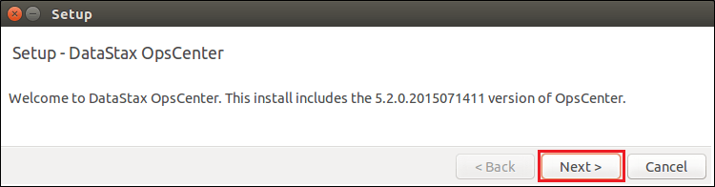](https://cdn.guru99.com/images/cassandra/021216_0520_DevCenterOp7.png)

This page provides OpsCenter version information. Press the next button

**Step 2)**After pressing next button, following page will be displayed.

[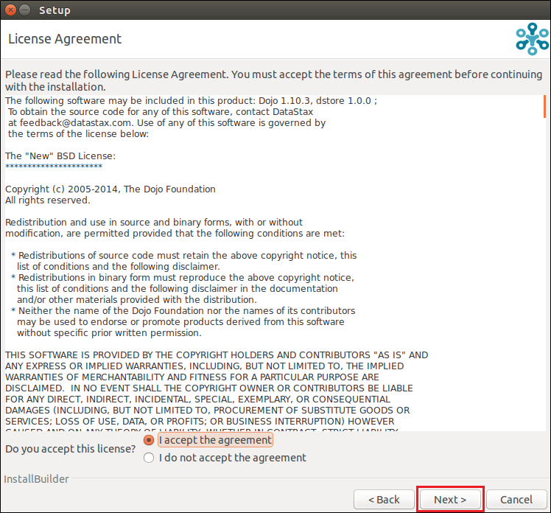](https://cdn.guru99.com/images/cassandra/021216_0520_DevCenterOp8.png)

This page is about the agreement. Accept the agreement and press the next button.

**Step 3)**After pressing the next button, following page will be displayed.

[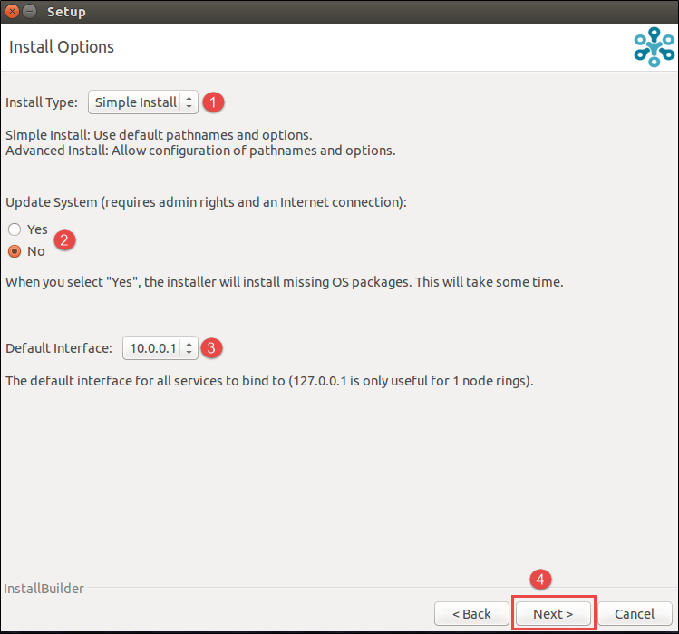](https://cdn.guru99.com/images/cassandra/021216_0520_DevCenterOp9.png)

This page asks about the installation options.

1. Select install type, choose Simple Install
2. Check no to update system
3. Select IP address of the machine.
4. Press the next button

**Step 4)**After pressing the next button following page will be displayed.

[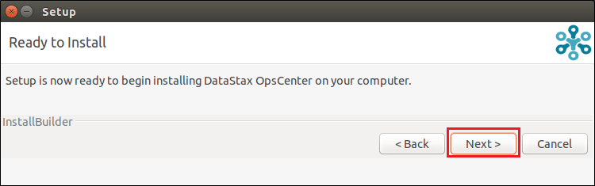](https://cdn.guru99.com/images/cassandra/021216_0520_DevCenterOp10.png)

OpsCenter is ready [to install](https://www.guru99.com/cassandra-devcenter-opscenter.html), press the next button

**Step 5)**After pressing the next button following page will be displayed.

[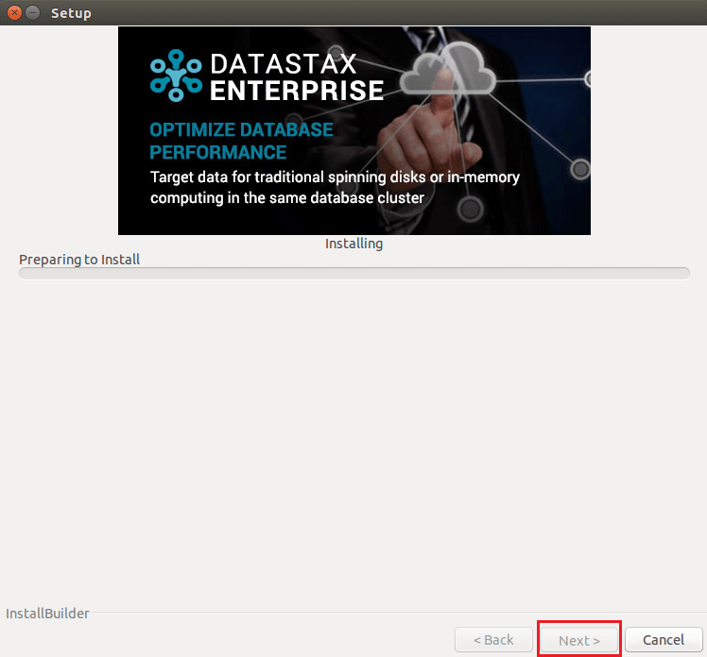](https://cdn.guru99.com/images/cassandra/021216_0520_DevCenterOp11.png)

Setup is being installed. After setup is successfully installed, press next button.

**Step 6)**After pressing next button following page will be displayed.

[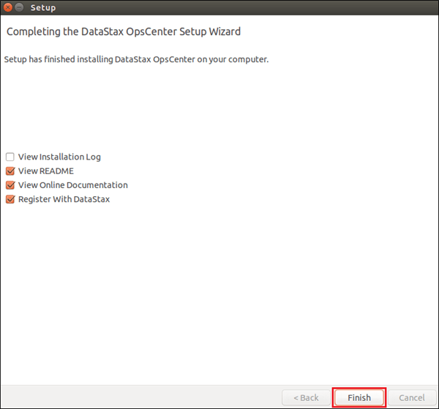](https://cdn.guru99.com/images/cassandra/021216_0520_DevCenterOp12.png)

Setup has been installed successfully, press finish button.

Before starting OpsCenter, Datastax agents needs to be installed on each node.

**Step 7)**First of all, you need to install Datastax agent on each node.

For installing datastax agent, go to the datastax-agent directory in the dse directory and run the below command.

[Datastax DevCenter & OpsCenter Installation Complete Guide](https://cdn.guru99.com/images/cassandra/021216_0520_DevCenterOp13.png)

After running this command, datastax-agent will be installed on the node. Do the same procedure for all the nodes in the cluster.

**Step 8)**For running OpsCenter, run the below command

[Datastax DevCenter & OpsCenter Installation Complete Guide](https://cdn.guru99.com/images/cassandra/021216_0520_DevCenterOp14.png)

After running the above command, OpsCenter will run successfully.

**Step 9)**For watching OpsCenter user interface, go to web browser and type in URL http://localhost:8888.

The following page will be displayed

[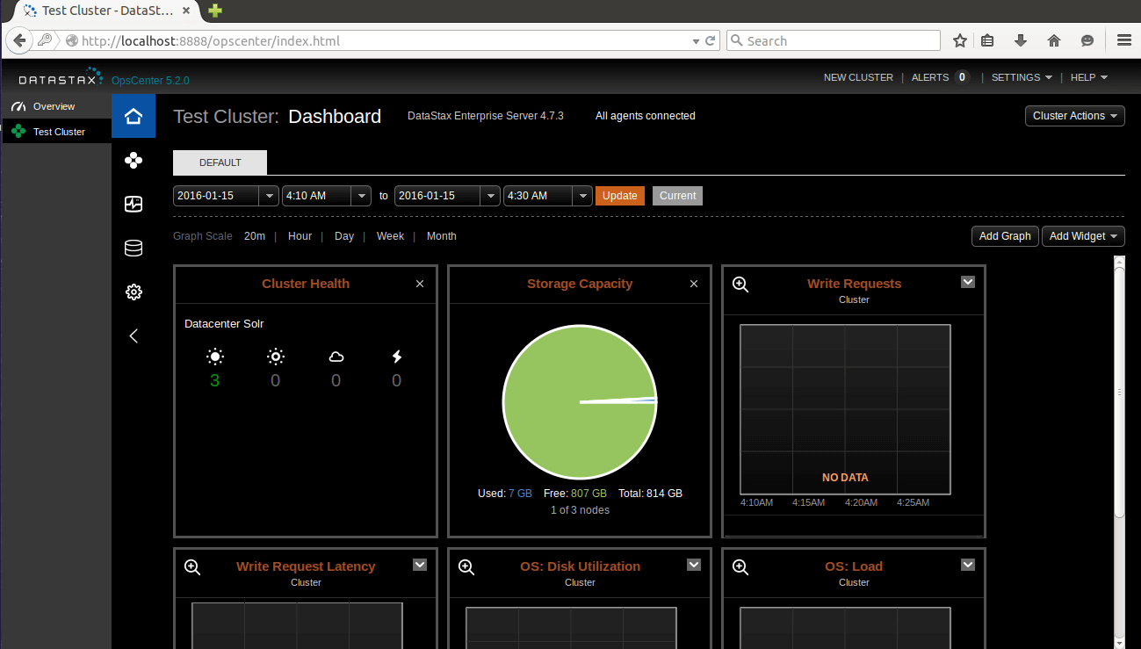](https://cdn.guru99.com/images/cassandra/021216_0520_DevCenterOp15.png)

Here is the monitoring tool where you can monitor all the nodes. You can find information how much space on the disk is filled and how much space remains.

**Summary:**

This tutorial explains installation procedure of OpsCenter also how datastax agent, OpsCenter is installed, and the commands used to install and run datastax agents and OpsCenter.